When type “concert-this” in the command line, the name of the venue, the venue location and

The date of the event is shown below in the three slides:

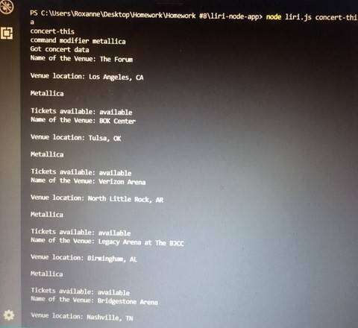

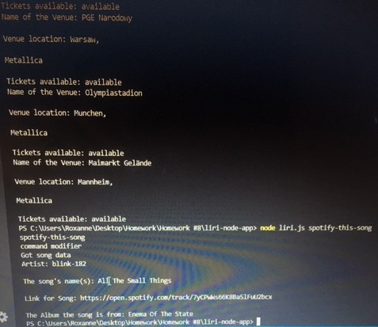

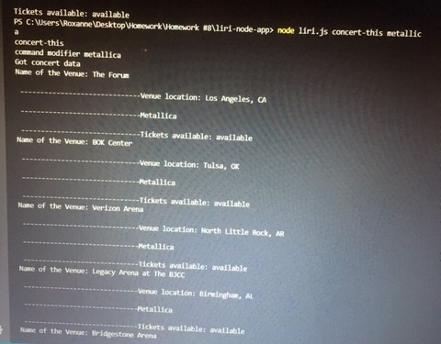

When I type“spotify-this-song” in the command line songs and the artist, the song name, a preview of the link to the song, the album the song is from appears as shown below:



When I run “movie-this” on the command line, it says “Get movie”.

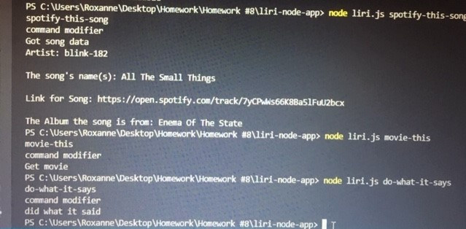

When “do-what-it-says” is typed in the command line, it says “did what it said”.

